Connect the e adapter and computer with a USB cable, open file *M43toEF_Expert_Tools_V1_0_0_20160205.exe* (password:67240872), Click “search” button, it will show Model, current version and Serial ID

Choose “0.7×” below “Optic Reducer” and click “Write” button

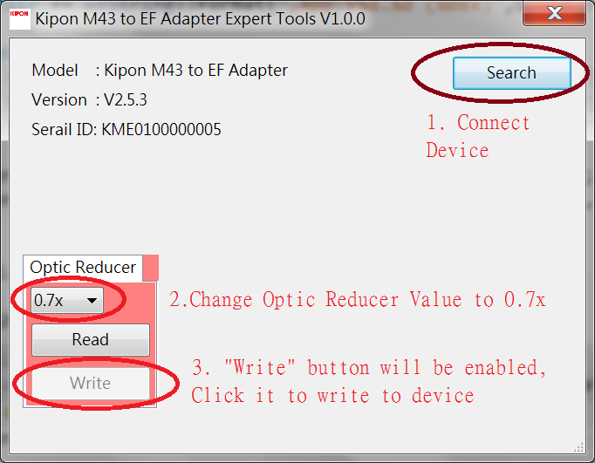

Open file KiponM43toEF_V2_9_0_20170928.exe, it shows as follow

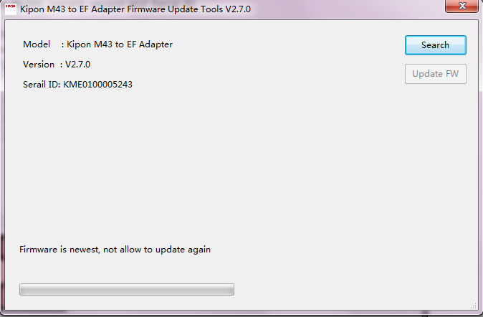

Click “Search” button,it will show Model, current version and Serial ID and then click “Update FW” to finish the update.